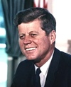
1. born 29th May, 1917
2. died 22nd Nov, 1963
3. Harvard University
4. four children
5. wife Jacqueline Lee Bouvier
6. US President with 43
7. initials JFK

Guess who? - John F. Kennedy
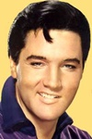
1. born 8th Jan, 1935
2. died 16th Aug, 1977
3. career start 1954
4. hometown Memphis
5. first hit “Heartbreak Hotel”
6. wife Priscilla
7. “King of Rock’n’Roll”

Guess who? - Elvis Presley
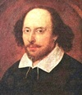
1. birthdate unknown, died 23rd April, 1616
2. age 18, wife Anne Hathaway
3. three children
4. actor and playwright
5. owner “King's Men”
6. famous sonnets + “Hamlet”

Guess who? - William Shakespeare
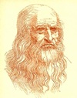
1. born 15th April, 1452
2. died 2nd May, 1519
3. Italian polymath
4. master: Andrea di Cione
5. work: arts and sciences
6. drawing “Vitruvian Man”
7. today Louvre: Mona Lisa

Guess who? - Leonardo Da Vinci

