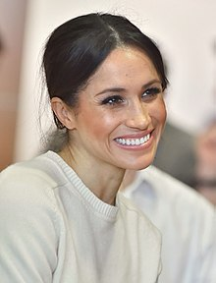
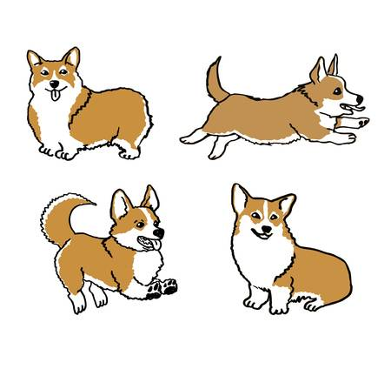
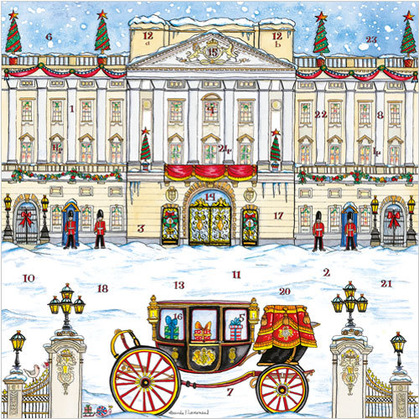
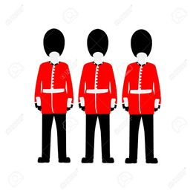
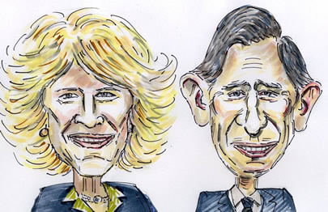
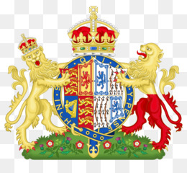
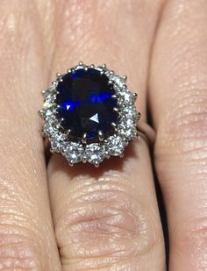
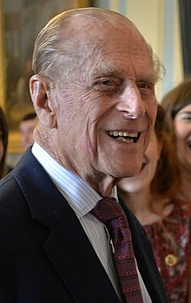
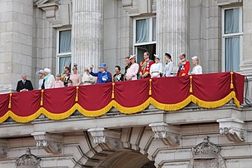
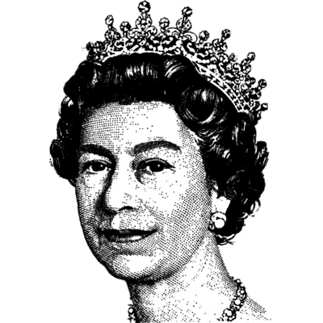
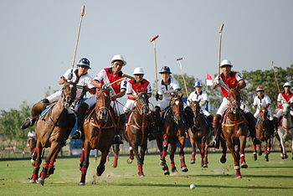
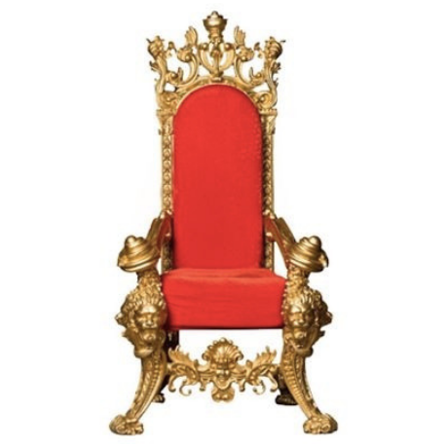
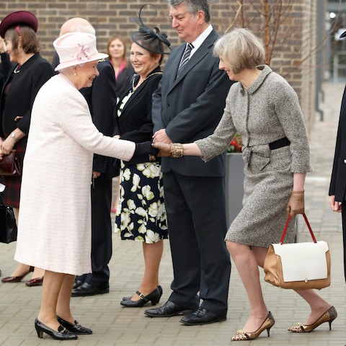
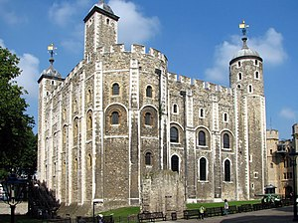
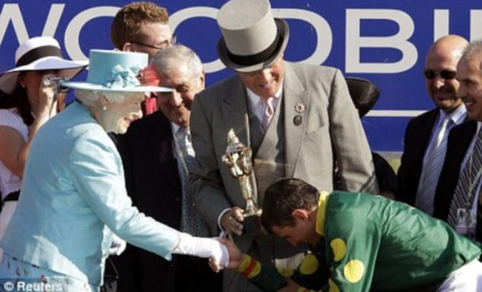
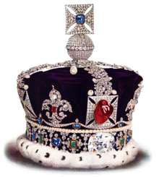
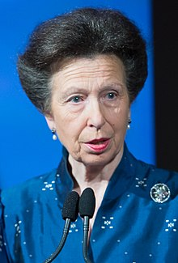
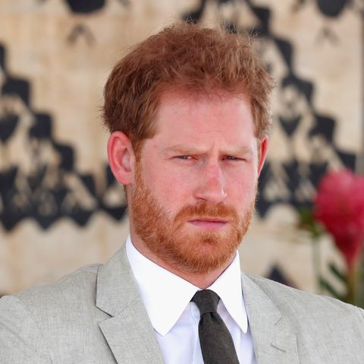
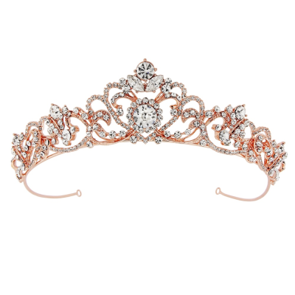

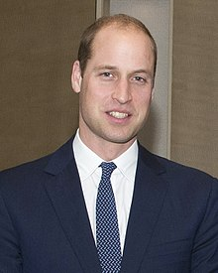
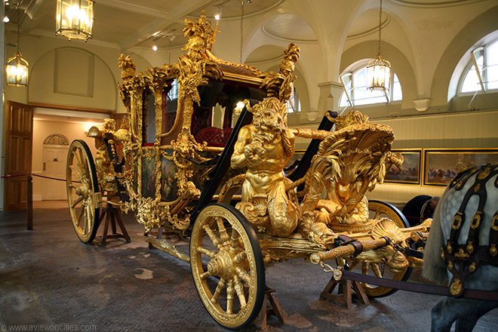

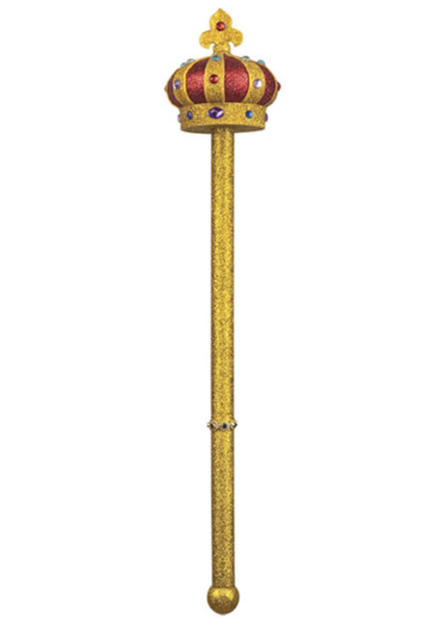

Meghan
Megan
Megen
a) Camilla
b)Kate Middleton
c) the Queen
a. corgis
b. Labradors
c. whippets
a. Canterbury Cathedral
b. Big Ben
c. Buckingham Palace
a. Soldiers
b. Beefeaters
c. Coldstream guards
a.The Queen and Prince Philip
b. Charles and Camilla
a) Queen Margaret I
b) Queen Elizabeth II
c) Princess Anne
a) Hockey
b) Lacrosse
c) Polo
a) throne
b) chair
c) sofa
a. arm of coats
b. coat of arms
c. football logo
a. bow
b. curtsy
c. wave hand
a.Tower of London
b. Buckingham Palace
c. Houses of Parliament
a) curtsy
b) shake hands
c) bow
a.the queen’s ring
b.Meghan’s ring
c.Kate’s ring
Crown
Tiara
Sceptre
a. Princess Man
b. Princess Can
c. Princess Anne
a) Prince William
b) Prince Harry
c) Prince Michael
a. Prince Charles
b. Prince Andrew
c. Prince Philip
a) in the garden
b) on the balcony
c) at the gate
a)Sophiw Wessex
b) Megan Markle
c)Sarah Ferguson
a) crown
b) necklace
c) tiara
a) Prince Harry
b) Prince William
c) Prince Edward
a)gold state coach
b)silver state coach
c)white state coach
a) Hillwalking
b) Fishing
c) Hunting
a) crown
b) throne
c) sceptre
Choose the correct answer.
1
2
3
4
5

9
8
7
6
10

14
13
12
11
15

20
19
18
17
16

21
23
22
25
24

